Algebra 1-2: 2.1 to 2.2 Review
Name: _______________________________Per: _____
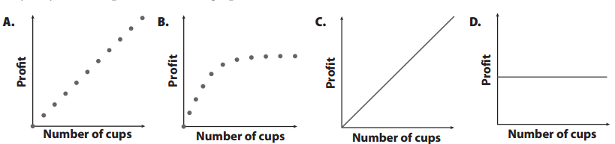
- Two children are selling lemonade. They charge $1 for a cup and only sell 10 cups. Consider the graphs shown.

- Which graph best represents the given situation? ____________ Explain your reasoning.

- What situations could the other graphs represent?

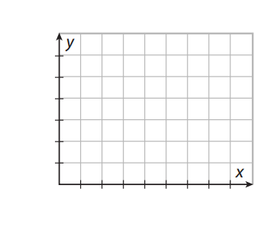
- A student taking a quiz earns 5 points for each correct answer. The quiz has a total of 7 questions.

- Will the graph be discrete or continuous?
- The domain is ___________________________
- The range is ___________________________
- Graph the situation using appropriate labels and scales.
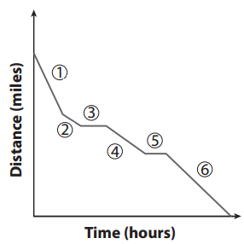
- Write a scenario to match the graph.

- You decide to hike up a mountain. You climb at a steady rate of 5 feet per minute for 2 hours, then take a 30 minute break for lunch. Then you continue to climb, at a rate double your previous speed for another 2 hours. When you make it to the summit, you enjoy the view for an hour. Finally, you decide to climb down the mountain at a rate of 15 feet per minute for 1 hour. Halfway down you pick up your pace to 25 feet per minute.
Use unit rates to graph each section.
*Graph distance FROM parking lot*
Section | Time (x) | Distance (y) from parking lot

- Find the Error: The graph shown was given to represent this problem. Find the error(s) in the graph. Then graph the problem correctly.
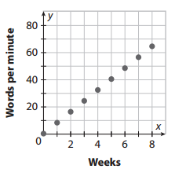
Jamie took an 8-week keyboarding class. At the end of each week, she took a test to find the number of words she could type per minute and found out she improved the same amount each week. Before Jamie started the class, she could type 25 words per minute, and by the end of week 8, she could type 65 words per minute.

- A 10-gallon water fountain is filled every 3 days. Between fills, it evaporates at a constant rate of 0.20 lbs per hour. (Note: a gallon of water weighs about 8 lbs.) Graph this scenario for 9 days.

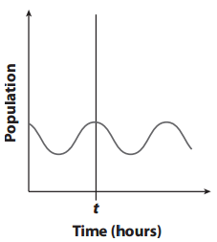
- Scientists are conducting an experiment on a bacteria colony that causes its population to fluctuate. The population of a bacteria colony is shown in the graph.
  - What happened to the bacteria colony before time t?

  - Suppose at time t, a second colony of bacteria is added to the first. Draw a new line on the graph to show how this action might affect the population after time t.

  - Suppose at some point after time t, scientists add a substance to the colony that destroys some of the bacteria. Describe how your graph from part b might change.

