1. A line of best fit must meet the following conditions:
   1. It matches the overall ____________________ and direction of the data.
   2. It has approximately the same number of points ___________________ the line as _________________ the line.
   3. 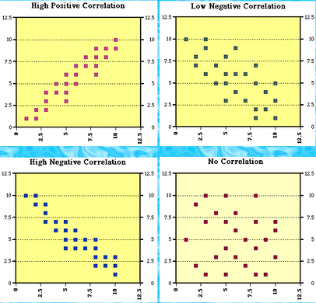Draw a line of best fit for the following scatterplots:

**For questions 2-7, determine whether the statement is TRUE or FALSE.**

1. ______ A scatterplot can be used to display correlation.
2. ______ The term correlation refers to how two variables vary independently of one another.
3. ______ When there is no pattern among the X and Y values, a negative correlation will result.
4. ______ The strength of a correlation depends on its sign, positive or negative.
5. ______ Correlation is the same thing as causation.
6. ______ A correlation value of r = -.9 is not as strong as a value of r = .5
7. Calculate the slope of the following:
   1. ( 6, 17) ( -2, 41) b. ( -8, 7) ( 2, 1) c. ( 9, 10) ( 9, 16) d. ( 5, -15) ( 6, -15)

1. 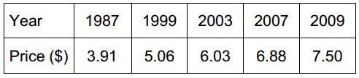The table shows the average price of a movie ticket for the year listed. Find the rate of change for each time interval (in unit rate). Round your answers appropriately
   1. 1987-1999 ______________ 1999-2003 ______________ 2003-2007 ______________ 2007-2009 ______________
   2. Which interval had the greatest rate of change? ____________
   3. What was the overall average rate of change? _______________

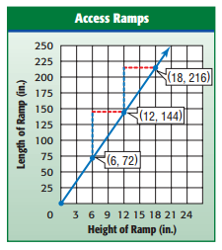

1. The graph shows the relationship between the height of a ramp and the length of a ramp. Find the slope of the line and explain what it means in the context of the problem.

1. Identify the slope and y-intercept, then write the equation of the line shown in the graph in slope intercept form

( ).

 a) b)

slope: _____ slope: ______

y-intercept:_____ y-intercept:_____

Equation: __________________ Equation: __________________

1. Maria works as a sales person. She makes a base salary of $850 a month plus 3% (.03) commission on anything she sells. Write a **function** in slope-intercept form to model Maria’s total monthly pay,  , in terms of the amount she sells,.
2. Mrs. Fuddy-Duddy doesn’t text a lot, so she decided to purchase a cellphone plan where she pays $0.10 per text message. She also has to pay $30 a month for minutes and data. Her monthly bill can be modeled by the function , where  represents the number of text messages she uses and  represents the total monthly cost.

**a)** Use the model to determine how much her bill would be if she sends only 234 text messages.

**b)** Use the model to determine how many text messages Fuddy-Duddy can send if she can spend $75 a month.

1. 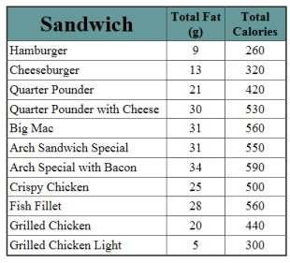The relationship between the fat grams, , and the total calories,  , in fast food as shown in the table at right can be modeled with the equation
 $$c(g)=11.73g+193.85$$

  1. What is the slope? ______________
   2. What does the slope represent in the context of the problem?
   3. What is the y-intercept? ______________
   4. What does the y-intercept represent in the context of the problem?
   5. The correlation coefficient for the model is $r= .93$. Explain what this means about the strength of the correlation between the two variables.

**Algebra 1-2 Unit 3 Test Study Guide Scoring Rubric**

|  |  |  |  |  |
| --- | --- | --- | --- | --- |
| Q # | Answer | Scoring | Points | Score |
| 1 | a – shape  b – above, below  Image result for scatter plotc- | a. 1point  b. 1 point each word  c. 1 point each line of best fit correctly drawn with shape and location appropriate (and none on last graph since no correlation) | 7 |  |
| 2-7 | 2) T 3) F 4) F 5) F 6) F 7) F | ½ point each | 3 |  |
| 8. | a. m= -3  b. m= $\frac{-3}{ 5}$ c. m= Undefined  d. m= 0 | 1 point each | 4 |  |
| 9. | 1987 - 1999 : $ 0.10 per year  1999-2003: $ 0.24 per year  2003 – 2007: $ 0.21 per year  2007 – 2009: $ 0.31 per year | Half credit for sign errors, etc. No credit for having fractions reversed | 4 |  |
| b. The 2007 – 2009 time period had the greatest ROC | Grade parts b and c relative to your calculations in part a. | 1 |  |
| c. Average ROC = $ 0.16 per year (round from 0.163) | 1 |  |
| 10. | 1. 12 | 1 point partial for correct fraction | 2 |  |
| 1. For every 1” increase in height, the ramp length increases by 12” | 1 point for increasing  1 point for correct context | 2 |  |
| 11. | Line a: slope -3, y-intercept 1, equation y = -3x +1  Line b: slope 2, y-intercept -1, equation y = 2x – 1 | 1 point for each item.  Grade equations relative to answers to slope and intercept | 6 |  |
| 12.  13. | $p(a)=.03a+850$ | 1 point for slope; 1 for intercept | 2 |  |
| 1. $53.40 | Grade relative to part a | 1 |  |
| 1. 450 text messages | Grade relative to part a; partial for setting up equation correctly | 2 |  |
| 14. | 1. 11.73 |  | 1 |  |
| 1. For each additional gram of fat, the calories increase by 11.73 | Grade relative to part a | 1 |  |
| 1. 193.85 |  | 1 |  |
| 1. The amount of calories with zero fat grams | Grade relative to part a | 1 |  |
| e) *The r-value is positive, so as fat increases, so do calories  * .93 is close to 1 (perfect correlation), so it is a strong positive relationship | 1 point  1 point | 2 |  |
| ***Total Points*** | | | ***41*** |  |