**Algebra 1-2: 4-1a Standard Form Homework**

Name: _______________________________ Per: _____

Find the  and  intercepts of each equation. Then graph the equation using the intercepts.

|  |  |  |  |
| --- | --- | --- | --- |
|  | |  | |
| - intercept | - intercept | - intercept | - intercept |
|  |  |  |  |

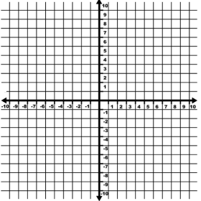

|  |  |  |  |
| --- | --- | --- | --- |
|  | |  | |
| - intercept | - intercept | - intercept | - intercept |
|  |  |  |  |



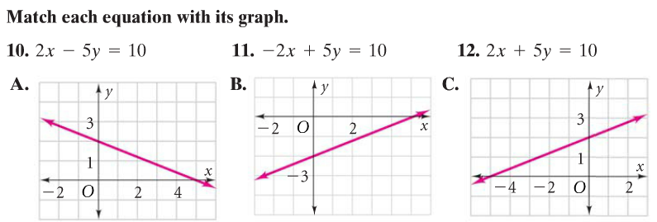5) Use intercepts to match the equations to their graphs.

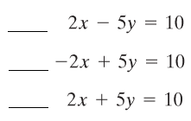

6) Lonnie runs at an average pace of 8 mi/h. He walks at 3 mi/h. He needs to cover a distance of 15 miles.

1. Write an equation to find the combination of walking and/or running he could do to cover 15 miles.
2. Find the intercepts
3. Interpret the meaning of the intercepts
4. Use your equation to find two different combinations of times spent running and walking that would cover a distance of 15 miles.

7. The student council is sponsoring a carnival to raise $450. Tickets cost $5 for adults and $3 for students.

1. Write an equation to find the number of each type of ticket that the club should sell.

b) Find the intercepts

1. Interpret the meaning of the intercepts
2. Use your equation to find two different combinations of adult/student tickets that would meet the student council’s goal.

**Algebra 1-2: 4-1b Point-Slope Form Homework**

Name: _______________________________ Per: _____

Write an equation in ***point-slope form*** that has the given slope and passes through the given point.

1. 
2. 
3. 
4. 
5. Match each equation to the pair of points used to create the equation. **Note**: the points may have been used as the points or to calculate the slope.

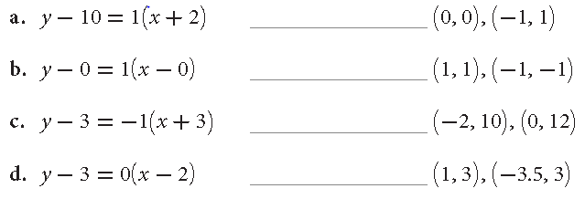

A line passes through the given points. Calculate the slope and then write two equations -- one using each point -- in ***point-slope form.***

1. 
2. 
3. 
4. Is the equation of the line through the point? Yes No

Justify your answer mathematically.

Model the data in each table with an equation in point slope form. **Use the first point in the table.**

1. 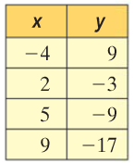
2. 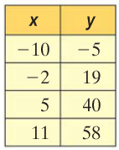
3. 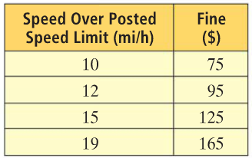
4. The relationship between pressure and depth under the ocean is linear. At the surface of the ocean, pressure is 1 atmosphere. At 66 ft. below sea level, the pressure is 3 atmospheres.
5. Define the variables and write a model for the data
6. Use your model to predict the pressure at 100 ft. **below sea level.**

**Algebra 1-2: 4-1c Equivalent Equations Homework**

Name: _______________________________ Per: _____

1) Determine if each pair of equations are equivalent.

$y-3=-3\left(x+4\right) and y=3x-9$

$y-5=2\left(x-2\right) and y=2x+1$

$y=5x-3 and y-2=5(x-1)$

$y=-2x-8 and y=-2(x-4)$

1. Rewrite each equation in intercept form.
$y-14=3(x-5)$

$y+5=-2(x+5)$

$6x+2y=24$

$3x+2y=6$

2. In each set of three equations, two are equivalent. Find them.
   1. i) $y-14=-2\left(x-5\right)$ ii) $y-30=-2(x+3)$ iii) $y+12=2(x-5)$
   2. i) $y+13=4\left(x+2\right)$ ii) $y-10=3(x-5)$ iii) $y+25=4(x+5)$
   3. i) $y-5=5\left(x-8\right)$ ii) $y-9=5(x+8)$ iii) $y-94=5(x-9)$
   4. i) $y+16=6\left(x+5\right)$ ii) $y-8=6(x-5)$ iii) $y-44=6(x-5)$
   5. Explain how you know the equations in parts a-d are equivalent.
3. Aidan took a hike on a Saturday morning. The table shows the cumulative number of calories she burned form the time she went to sleep Friday night until she finished her hike.

|  |  |  |  |  |
| --- | --- | --- | --- | --- |
| Time hiking (min) | 5 | 10 | 15 | 20 |
| Calories Burned | 568 | 591 | 614 | 637 |

* 1. Write a point-slope equation of a line that fits the data.
  2. Rewrite the equation in intercept form.
  3. What are the real-world meanings of the slope and y-intercept in this situation?
  4. Could you use the equation $y-821=4.6(x-60)$ to model this situation? Explain why or why not.
  5. What is the real-world meaning of the point used to write the equation in 4d?

**Algebra 1-2: 4-2a Fitting a Line to Data Homework**

Name:___________________________ Per: _____

1. To be a good representation of the data, a line of best fit must fit the general ___________________ of the data, and have about the same number of points ________________the line and ________________ the line.
2. For each graph below, determine whether a linear model is reasonable. If so, draw a trend line and select two points you would use if you were going to write a linear model for the data.

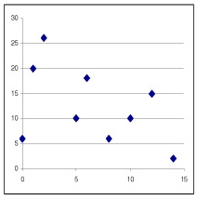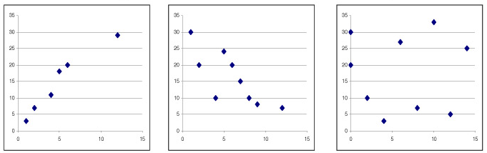

Graph 1 Graph 2 Graph 3 Graph 4

1. Think back to our prior unit where we discussed correlation.
   1. ***Estimate*** the r-value for each of the graphs in problem 2.
      * 1. 2. 3. 4.
   2. Do you think the r-value has a relation to the reliability of the model? Explain.
2. The numbering system used in Europe for shoe sizes is different from the system used in the United States. Use the data in the table to create a model for converting between systems.

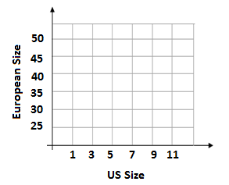

|  |  |
| --- | --- |
| U.S. Size | European Size |
| 1 | 31 |
| 3 | 34 |
| 5 | 36 |
| 7 | 39 |
| 9 | 41 |
| 11 | 44 |

1. Graph the data.
2. Use the points (1, 31) and (11, 44) to write an equation for a trend line. Convert your final equation to slope-intercept form.
3. Use your equation to find the European equivalent of U.S. size 8.

|  |  |
| --- | --- |
| Age (years) | Energy Needed (Calories) |
| 1 | 1100 |
| 2 | 1300 |
| 5 | 1800 |
| 8 | 2200 |
| 11 | 2500 |
| 14 | 2800 |
| 17 | 3000 |

1. The table shows the average daily energy requirements for male children and adolescents.

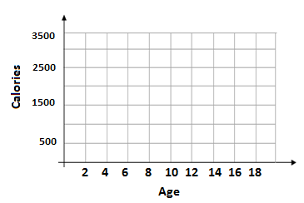

1. Graph the data.
2. Model the data with a linear equation using the points (5, 1800) and (14, 2800) . Convert your final equation to slope-intercept form.
3. Estimate the daily energy requirements for a male 16 years old.
4. Do you think your model also applies to adult males? Explain.

**Algebra 1-2: 4-2c Regression Lines Homework**

Name:___________________________Period:_____

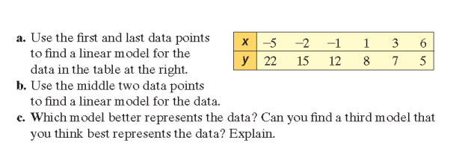

For problems 1-4, use the data in the table at right. Write all equations in slope-intercept form.

1. Use the first and last data points to find a linear model for the data.
2. Use the middle two data points to find a linear model for the data.
3. Use second and fifth points to find a linear model.
4. Use regression on your calculator to find the line of best fit. ___________________________________.
5. Compare the three equations you calculated to the linear regression. Which model best matches the regression line?
6. Explain how choosing points affects the accuracy of a model.

For each data set in problems 7-9, enter the data into the graphing calculator to find a line of best fit. Round to the nearest hundredth. List the correlation coefficient and explain what it means relative to the data.

1. {(-5, 6.3), (-4, 5.6), (-3, 4.8), (-2, 3.1), (-1, 2.5), (0, 1.0), (1, -1.4)}

Line of Best Fit: ___________________________ Correlation Coefficient:_______

What the correlation coefficient means in the context of the problem:

|  |  |  |  |  |  |  |
| --- | --- | --- | --- | --- | --- | --- |
| Year | 1992 | 1993 | 1994 | 1995 | 1996 | 1997 |
| National Health Expenditures (billions of dollars) | 836.5 | 898.5 | 947.7 | 993.7 | 1042.5 | 1092.4 |

Line of Best Fit: Correlation Coefficient:

What the correlation coefficient means in the context of the problem:

|  |  |  |  |  |  |  |  |  |  |  |
| --- | --- | --- | --- | --- | --- | --- | --- | --- | --- | --- |
| State | AL | FL | IN | KY | LA | NC | OK | SC | TN | VA |
| Population (millions) | 4.0 | 12.9 | 5.5 | 3.7 | 4.2 | 6.6 | 3.1 | 3.5 | 4.9 | 6.2 |
| Representatives | 7 | 23 | 10 | 6 | 7 | 12 | 6 | 6 | 9 | 11 |



Line of Best Fit: Correlation Coefficient:

What the correlation coefficient means in the context of the problem: