**Algebra 1-2: 4-1a Standard Form of Linear Equations**

I will: Model linear relationships using standard form

|  |  |  |  |  |  |
| --- | --- | --- | --- | --- | --- |
| **Standard Form:** | | | | | |
|  |  |  |  | = |  |
| Positive  Integer $$≠0$$ |  | Integer $$≠0$$ |  | Integer |

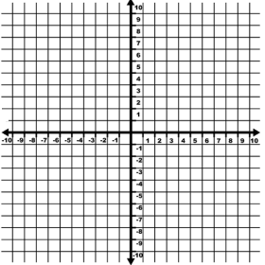**Investigation: *x and y Intercepts***

1. Complete the table of values for the equation: 

|  |  |  |  |  |  |
| --- | --- | --- | --- | --- | --- |
| $$x$$ | -3 | 0 | 3 | 6 | 9 |
| $$y$$ |  |  |  |  |  |

1. Use the table to graph the equation.
2. What is the  Intercept? _________
3. What is the value of when the line crosses the -axis? ________
4. In the equation what is:
   1. The value of when ? ____________
   2. The value of when ?_____________
5. Using your answers, explain how you could make a graph of an equation in standard form without making a table.

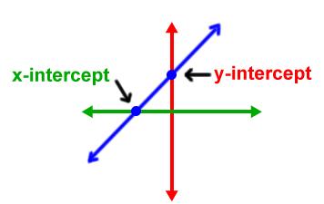

|  |  |  |
| --- | --- | --- |
| ***x and y Intercepts:*** | | |
| Intercept | Intercept | |
| ( , 0) | (0, ) | |
| where the line crosses the  ___________________ | | where the line crosses the    ___________________ |

1.  

 Intercept: ( , 0)  Intercept: (0, )

1. The Corona Grows club has a booth at the bonfire. They're selling water bottles for $2 each and face painting for $3. They need to raise $450 to refurbish the green house.
2. Define the variables and write a model of this scenario.
3. Find and interpret the intercepts
4. Use your model to identify two different combinations of water bottle and face painting sales that would allow the club to meet their goal.

Try it out!

**Algebra 1-2: 4-1b Point-Slope Form of Linear Equations**

I will: Model linear relationships using point-slope form

|  |  |  |  |  |
| --- | --- | --- | --- | --- |
| **Point-Slope Form:** | | | | |
|  |  |  |  |  |
| Variable  Dependent  Output  Range |  | Variable  Independent  Input  Domain |  |  |

1. Identify the point and slope from each of the following equations:
   1.  b.  c. 
2. Does the equation of any of the lines in question 1 pass through the point ? Justify your answer.

1. Find the line that passes thru (3, -6) and slope of 2

***What if we don’t know the ROC?***

1. 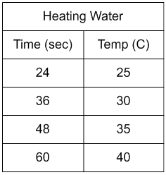
2. Since the time Beth was born the population of her town has increased by a rate of 850 people per year. On Beth's 9th birthday the population was 307,650.
   1. Define the variables and write a model for the population of Beth’s town.
   2. If the rate of growth continues, what will the population be on Beth's 16th birthday?
3. Find the line that passes thru (3, 6) and (6, 9)

Find slope:

Use Point 1 Use Point 2

Try it out!

**Algebra 1-2 4-1c Equivalent Equation**

I will: Convert forms of linear equations and determine if equations are equivalent.

|  |  |  |
| --- | --- | --- |
| **3 Forms of Linear Equations** | | |
|  |  |  |
|  |  |  |
| * Easy to ________________ * Easy to see ______________ * Fits many real-world problems | * Easy to graph with   _____________________   * Fits many real-world problems | * Only used to get to the other forms * Used when you have: |

Converting Point-Slope to Slope-Intercept

1. Distribute  through parentheses
2. Combine like terms (constants)

a)

b)

Converting Standard to Slope-Intercept

1. Move  -term to right side.
2. Divide everything by coefficient of 

a)

b)

________________________________________INVESTIGATION_______________________________________

Rewrite each equation into slope-intercept form, then determine which equations are equivalent.

$y=2\left(x-2.5\right)$

$y-18=2\left(x-8\right)$

$y-52=-6\left(x+8\right)$

$y+6=2\left(x+4\right)$

$y-21=-6\left(x+4\right)$

$y+14=-6\left(x-3\right)$

$y+10=2\left(x+6\right)$

$6x+y=4$

$y-11=2\left(x-8\right)$

$12x+2y=-6$

$y-10=2\left(x-4\right)$

$y-15=-2\left(10-x\right)$

$y-7=2\left(x-6\right)$

$6x+y=-3$

$y-16=-6(x+2)$

Explain how you can tell two equations in different forms are equivalent

**Algebra 1-2: 4-2a Fitting a Line to Data**

I will: Fit a linear function to a set of data and use it to solve problems

|  |  |
| --- | --- |
| **Fitting a Line to data:** | * Fits the shape of the data (models the relationship) * Has about the same number of points above the line as below the line. * Distances from the points to the line are as short as possible. * Does not necessarily include points from the data set. |

This table shows the relationship between the number of years a person might be expected to live and the year he or she was born. Life expectancy is a prediction that is very useful in professions like medicine and insurance

1. Graph the data points, let *x* represent birth year, and let *y* represent life expectancy in years. Use different colors to represent the male and female data.

**U.S. Life Expectancy at Birth**

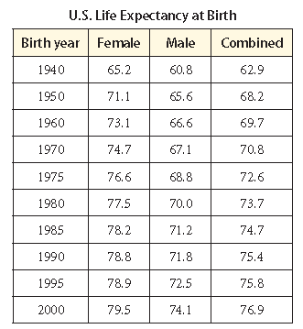

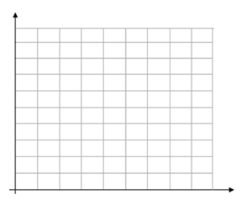

1. Choose two points on your graph so that a line through them closely reflects the pattern of all the points on the graph for the gender. Use the two points to write the equation of this line in **point-slope form.**

|  |  |
| --- | --- |
| Female | Male |
|  |  |

1. Use your equations from #2 to predict the life expectancy of a person who will be born in 2022.

|  |  |
| --- | --- |
| Female | Male |
|  |  |

1. Compare your prediction from #3 to the prediction that another group made analyzing the same data. Are your predictions the same? Are they close? Explain why it’s possible to make different predictions from the same data.
2. Compare the slope of your line of fit to the slopes that other groups found working with different data sets. What does the slope for each data set tell you?

**Algebra 1-2: 4-2b Fitting a Line to Data Practice**

|  |  |  |  |  |  |  |
| --- | --- | --- | --- | --- | --- | --- |
| **Altitude (ft)** | 7,500 | 8,200 | 8,600 | 9,200 | 9,700 | 10,400 |
| **Temperature (°F)** | 61 | 58 | 56 | 53 | 49 | 46 |

1. In most cases, the temperature decreases with increasing altitude. The table shows the temperatures (°F) at the given altitudes (feet).

|  |  |
| --- | --- |
| **a)** Graph the data points | **b)** Develop a linear model for the relationship between altitude and temperature.  Use (9000, 52) and (8000, 585) as your points for your model |
| **c)** Estimate the temperature at an altitude of 12,000 ft. |
|  |  |

1. Joey has a treadmill that gives an estimate of the number of calories he burns during a workout. The table give the workout times and calories burned for several workouts.

|  |  |  |  |  |  |  |
| --- | --- | --- | --- | --- | --- | --- |
| **Time (minutes)** | 18 | 24 | 30 | 40 | 48 | 52 |
| **Calories Burned** | 260 | 280 | 320 | 380 | 440 | 475 |

|  |  |
| --- | --- |
| **a)** Graph the data points. | **b)** Develop a linear model for the relationship between workout time and calories burned.  Use (24,280) and (48, 440) as your points for your model |
| **c)** Estimate the number of calories Joey would burn if he worked out for 75 minutes. |

1. The table gives the weight in tons and estimates the over fuel economy in miles per gallon for several cars.

|  |  |  |  |  |  |  |
| --- | --- | --- | --- | --- | --- | --- |
| **Weight (tons)** | 1.3 | 1.4 | 1.5 | 1.8 | 2.1 | 2.4 |
| **Miles per Gallon** | 29 | 24 | 23 | 21 | 17 | 15 |

|  |  |
| --- | --- |
| **a)** Graph the data points. | **b)** Develop a linear model for the relationship between weight and miles per gallon. Use the most appropriate points for your model based on your line of best fit |
| **c)** Estimate the fuel economy for a car that weighs 2.25 tons. |

Mixed Review

1. Carlota wrote the equation  for the line passing through the points ( –1, 3 ) and ( 2, 9 ) Explain and correct her error.
2. Opal walked from school to home, which was a distance of 12 miles. She walked at a rate of 4 miles per hour. The graph represents the remaining distance Opal had to walk.
3. 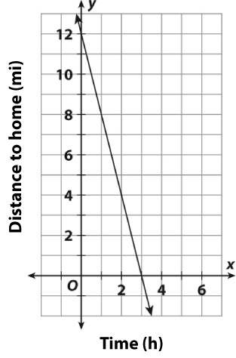Find the slope of the line.

1. Find the *x*-intercept, and explain what it represents in the context.
2. Find and interpret the *y*-intercept.

d. Write an equation for the line in slope-intercept form.

**Algebra 1-2: 4-2c Lines of Best Fit and Correlation with Graphing Calculator**

You will model data sets using technology



**Example:** The AZ State Fair held its annual pie and hot dog eating contest. Only five contestants entered the contest. The results are displayed as data points of (pies eaten, hot dogs eaten) (pies horizontal, hot dogs vertical) .

1. Draw a scatter plot and trend line.
2. Use two points from the data set to write an equation

for a line of best fit.

1. Enter the data into the calculator using the steps below.
2. List the equation of the line of best fit below and compare it to the one you calculated in (b). Why is it different?
3. List the correlation coefficient. What does this mean?

**SCATTER PLOTS ON THE GRAPHING CALCULATOR**

* If you have a TI-84, you need to start by turning on the Stat Diagnostics

Step 1: Hit **MODE**

Step 2: Scroll down until you see **STAT DIAGNOSTICS** and make sure **ON** is highlighted

**Entering Data into the Calculator**

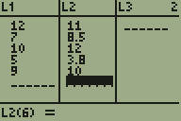Step 1: Hit **STAT**

Step 2: Select **1:EDIT**

Step 3: Type in the x-coordinates in **L1** (Hit enter after typing in each value)

Step 4: Type in the y-coordinates in **L2** (Hit enter after typing in each value)

**Getting the Linear Model for the Data**

Step 1: Hit **STAT**

Step 2: Move to the right to **CALC**

Step 3: Select **4:LinReg** by hitting **ENTER**

Step 4: Scroll down to **CALCULATE** and hit **ENTER**

* Note: If your calculator does not say **CALCULATE**, then just hit **ENTER**

|  |  |  |
| --- | --- | --- |
| Step 2 | Step 4 | After hitting enter from Step 4 |

You Try!

1) For each problem below, enter the data into the graphing calculator to find a line of best fit. For each data set, enter the data into the graphing calculator to find a line of best fit. Round to the nearest hundredth. List the correlation coefficient and explain what it means relative to the data.

|  |  |
| --- | --- |
| Year | # Bikes Produced (millions) |
| 1993 | 9.9 |
| 1994 | 9.7 |
| 1995 | 8.8 |
| 1996 | 8.0 |

Interpret the Contextual meaning of the slope:

Line of Best Fit: Correlation Coefficient:

Explain what the correlation coefficient means in the context of the problem:

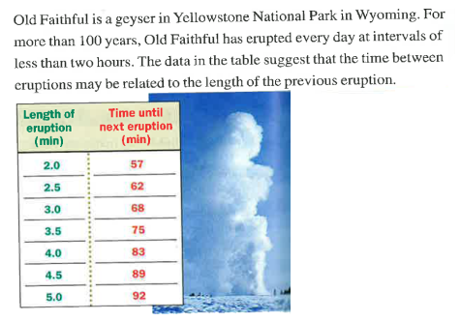2)

Line of Best Fit:

Correlation Coefficient:

Explain what the correlation coefficient means in the context of the problem:

**Algebra 1-2: 4-2d Linear Models in the Real World**

You will: Develop and interpret models for real-world linear applications

|  |  |  |
| --- | --- | --- |
| **Topic:** | | **Make a prediction using the model** |
| **Linear Model (equation)** | **Correlation Coefficient:** | The population of Oregon was approximately 3 million. About how many drivers lived in Oregon that year? |
| **Rate of Change & What it means for this problem** | |

|  |  |  |
| --- | --- | --- |
| **Topic:** | | **Make a prediction using the model** |
| **Linear Model (equation)** | **Correlation Coefficient:** | If a deluxe hamburger has 900 calories, about how many grams of fat would the hamburger contain? |
| **Rate of Change & What it means for this problem** | |

|  |  |  |
| --- | --- | --- |
| **Topic:** | | **Make a prediction using the model** |
| **Linear Model (equation)** | **Correlation Coefficient:** | What do you predict the time form the 100-meter dash will be in the 2016 Olympics? |
| **Rate of Change & What it means for this problem** | |

|  |  |  |
| --- | --- | --- |
| **Topic:** | | **Make a prediction using the model** |
| **Linear Model (equation)** | **Correlation Coefficient:** | What would the approximate average high in June be for a city with a latitude of 40°? |
| **Rate of Change & What it means for this problem** | |

|  |  |  |
| --- | --- | --- |
| **Topic:** | | **Make a prediction using the model** |
| **Linear Model (equation)** | **Correlation Coefficient:** | What do you predict the median base salary to be in 2015? |
| **Rate of Change & What it means for this problem** | |

|  |  |  |
| --- | --- | --- |
| **Topic:** | | **Make a prediction using the model** |
| **Linear Model (equation)** | **Correlation Coefficient:** | What do you predict the attendance to be in 2015? |
| **Rate of Change & What it means for this problem** | |