Design your Olmec Giant Stone Head!
You are a ruler for the Olmec people and it has come time to begin constructing your stone head. Don’t forget, your stone head will only remain while you are alive or if you remain in power. So best not be overthrown!
In the space provided, design your stone head.

- Describe the features of your giant stone head. Include any elements of Mayan culture that you added and why.
______________________________________________________________________________________________________________________________________________________________________________________________________________________________________________________________________________________________________________________________________________________________________________________________________________________________________________________________________________________________________________________________________________________________________________________________________________________________________________________________________________________________________________________________Now that you have your giant stone head sketched out, you need to figure out how it is going to be moved to its permanent resting place in La Venta. As ruler, it is your job to work out how it will be constructed and moved.

- Who will be constructing your stone head?
____________________________________________________________________________________________________________________________________________________________________________________________________________________________________________________________________________________________________________
- How heavy is your stone head? ____________________________________________
- How far does your stone head need to travel? ______________________________
- Map out the route your workers will need to take in order to move your stone head:
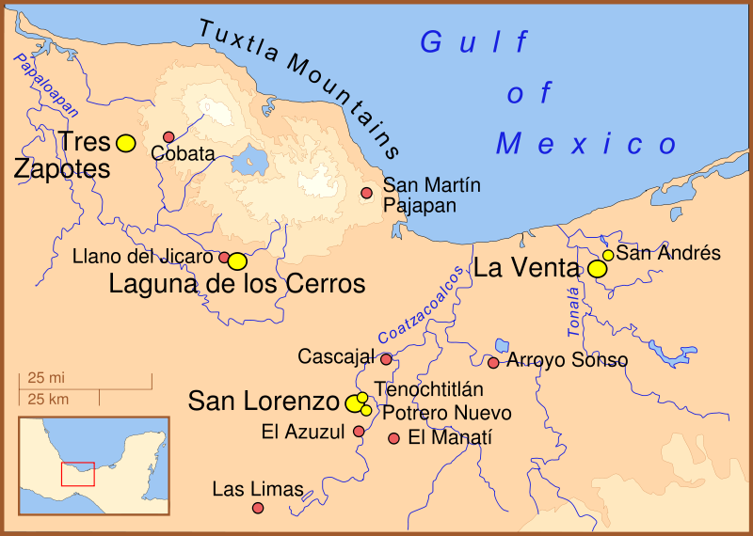
YOU ARE HERE!
- Now, describe how your workers are going to move your stone head. (Remember: you do not have any modern technology! You only have the basic stone tools and natural elements available to you)
______________________________________________________________________________________________________________________________________________________________________________________________________________________________________________________________________________________________________________________________________________________________________________________________________________________________________________________________________________________________________________________________________________________________________________________________________________________________________________________________________________________________________________________________________________________________________________

