**Algebra 1-2: 3.1 to 3.3 Review NAME: \_\_\_\_\_\_\_\_\_\_\_\_\_\_\_\_\_\_\_\_\_\_\_\_\_\_\_ Per: \_\_\_\_\_**

1. Match the correlation coefficients to the graph: ****

\_\_\_\_\_\_\_ \_\_\_\_\_\_\_ \_\_\_\_\_\_\_ \_\_\_\_\_\_\_ \_\_\_\_\_\_\_

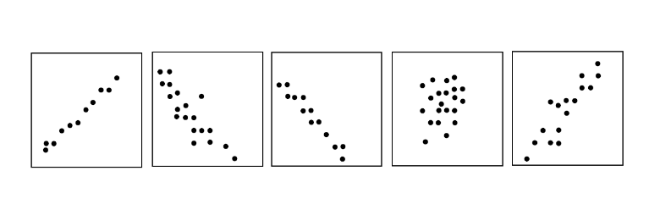

1. Find the slope of each line.

1. 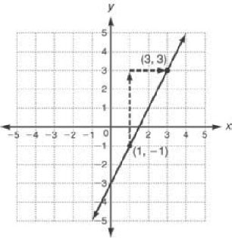 2. 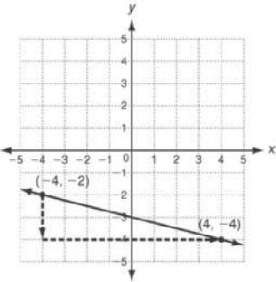 3. 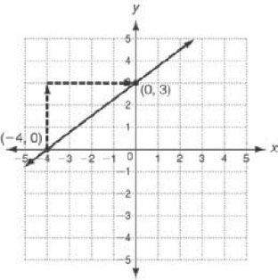

4. 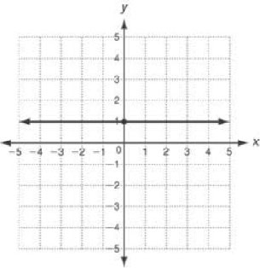 5. 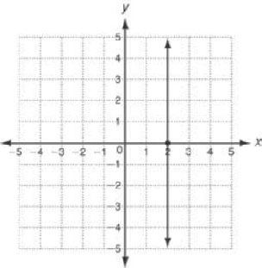 6. 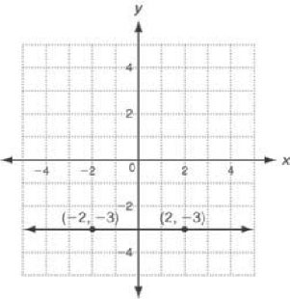

1. Find the rate of change or slope of the line containing each pair of points.

(4, 5) and (11, 33) (4, 8) and (3, 9)

(0, 8) and (3, 3)  and 

1. The table shows a truck driver’s distance from home during one day’s deliveries. Find the rate of change for each time interval.

|  |  |  |  |  |  |  |
| --- | --- | --- | --- | --- | --- | --- |
| **Times (h)** | 0 | 1 | 4 | 5 | 8 | 10 |
| **Distance (mi)** | 0 | 35 | 71 | 82 | 199 | 200 |

Hour 0 to Hour 1: \_\_\_\_\_\_\_\_ Hour 1 to Hour 4: \_\_\_\_\_\_\_\_ Hour 4 to Hour 5: \_\_\_\_\_\_\_

Hour 5 to Hour 8: \_\_\_\_\_\_\_\_\_ Hour 8 to Hour 10: \_\_\_\_\_\_\_\_\_

1. The table shows the year and the cost of sending 1-ounce letter in cents. In which interval did the cost increase at the greatest rate?

|  |  |  |  |  |  |  |
| --- | --- | --- | --- | --- | --- | --- |
| Year | 2003 | 2004 | 2006 | 2008 | 2013 | 2014 |
| Cost (cents) | 37 | 37 | 39 | 42 | 46 | 49 |

1. Use rates of change to determine if the functions are linear. Justify your answers.
   1. 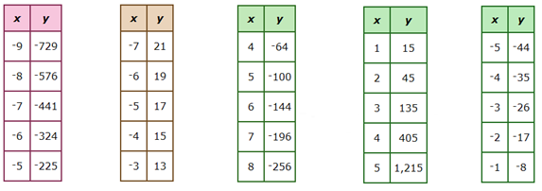 b.
2. A line has a slope of  . Which of the following sets of points could be on the line?



1. The cost, in dollars, charged by an electric company for energy depends upon the number of kilowatt-hours used. Using the points (600, 60) and (1000, 112), find the average rate of change in the cost of electricity.

|  |
| --- |
| 1. Find the rate of change for the following linear functions and explain what it means for each situation.   http://mdk12.org/assessments/high_school/look_like/2002/algebra/images/13alg.gifhttps://www.ncetm.org.uk/public/files/210142/AW_D8aa.jpg  a) b)  A1_MTXEDI363113_131TA1_MTXEDI363113_130Tc) d) |